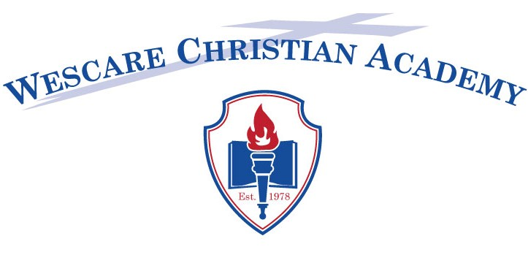

2020-2021
HANDBOOK ACKNOWLEDGEMENT

We, the undersigned, parent(s)/guardian of_________________________(Student Name) enrolled in Wescare Christian Academy have received and have read, or have had read to us, the foregoing Code of Student Conduct. I agree to abide by all rules set forth in this handbook.

We also agree to support / help with each fundraiser for the entire year.

We further accept the responsibility to pay for any charges that are incurred as a result of an accident at school that are not covered by the health insurance plan carried by the academy.

__________________________________ _______________________________
Parent Signature Parent Signature

__________________________________ _______________________________
Parent Print Name Parent Print Name

Date: _______________________________

NOTE: Both parents signature required if living in the same household. If the student lives with only one parent or guardian, only one is expected to sign.

