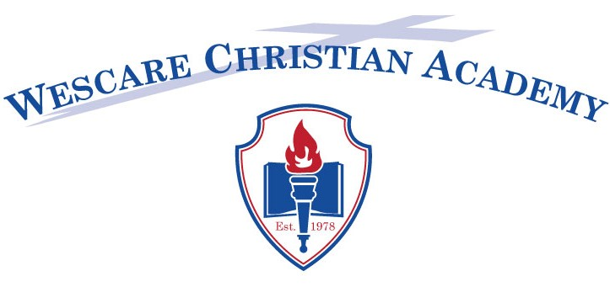

Children’s Photograph Release

Name of Child: __________________________________________________

We often take photographs of the children during daily activities. These pictures may be used on occasion in printed publications, on our website/Facebook, and/or in local newspapers. To take your child’s picture, we need your permission. Please answer the questions below, then sign and date this form where indicated and return to the office.
- May we photograph your child for use in materials produced by WCA? YES NO
- May we photograph your child for use in the classroom (i.e., collages, bulletin boards, crafts, or other activities)? YES NO
- May we use your child’s photograph on our website/Facebook? YES NO
- May we video your child for special presentations such as Wescare Sunday, Graduation, etc? YES NO
- Occasionally, we submit articles or pictures to the local press to promote special events such as graduation. May we use your child’s photograph in this way? YES NO

_________________________________________ _____________________
Parent/Guardian’s Signature Date

__________________________________________________________
Please print child’s name

