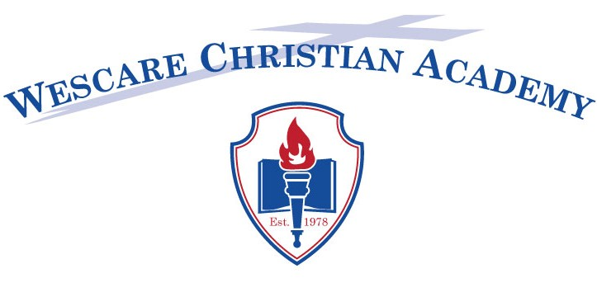
1368 NC HWY 134 N, Troy, NC 27371
Phone: (910)572-2270 Fax:(910)572-2257
wescaresecretary@gmail.com

Request for Student Records

Please send (Fax, Email or mail) the following checked documents as soon as possible:

- Grades as of the date of withdrawal from your school
- Attendance Records
- Immunization records
- Gifted/Exceptional Children’s Records (Include DEC3)
- Discipline/Behavioral Records

~~~~~~~~~~~~~~~~~~~~~~~~~~~~~~~~~~~~~~~~~~~~~~~~~~~~~~~~~

Authorization to School

Student’s Name_______________________________________________________________
First Middle Last

Current Grade Level ______ Name of Last School attended ___________________________

I hereby authorize the release of all records concerning the above-named student to Wescare Christian Academy in Troy, North Carolina, to which the student has applied for admission.

Parent(s)/Legal Guardian(s) Signature: _________________________________ Date: _______________

